AlzLife: Alzheimer’s Disease Therapy using 40Hz Light

Bailey Brake, Ruohui Huang, Emily Lampat, Khang Le, Yuri Zhang

**Abstract**— Alzheimer’s Disease affects more than 6 million Americans to date, where 1 in 3 seniors die from either Alzheimer’s or another form of dementia. Current treatments are inconvenient and inaccessible due to patients’ hesitation to reach out early, as well as Primary Care Provider (PCP) lack of resources in diagnosing. To help healthcare professionals and neuroscientists in their effort of treating and alleviating the issues of inaccessibility to Alzheimer’s treatment, we propose a noninvasive sensory stimulation therapy that exposes patients to 40Hz light, where a LED panel can be attached at the back of any individual’s smartphone and have it display white bright light that flickers at a rate of 40Hz. By having patients exposed to this light, it will promote cells and fluids important for various brain waste-clearance mechanisms that are important in eliminating debris and plaques known to cause Alzheimer’s.

**Index Terms**— Alzheimer’s Disease, 40Hz light, sensory stimulation, gamma entrainment

————————————————

* *Bailey Brake is with the Department of Electrical and Computer Engineering, Boston University, Boston, MA 02215. E-mail:* [*bbrake01@bu.edu*](mailto:bbrake01@bu.edu)
* *Ruohui Huang is with the Department of Electrical and Computer Engineering, Boston University, Boston, MA 02215. E-mail:* [*rhhuang@bu.edu*](mailto:rhhuang@bu.edu)
* *Emily Lampat is with the Department of Electrical and Computer Engineering, Boston University, Boston, MA 02215. E-mail:* [*lampat26@bu.edu*](mailto:lampat26@bu.edu)
* *Khang Le is with the Department of Electrical and Computer Engineering, Boston University, Boston, MA 02215. E-mail:* [*khang@bu.edu*](mailto:khang@bu.edu)
* *Yuri Zhang is with the Department of Electrical and Computer Engineering, Boston University, Boston, MA 02215. E-mail:* [*zyuri@bu.edu*](mailto:zyuri@bu.edu)

—————————— ◆ ——————————

# 1 Background for the Project

## 1.1 Clinical Background

The basis on which this project is founded is novel research into gamma frequency sensory stimulation. In summary, recent research has found that stimulation from an external source at a specific frequency of 40 Hz, whether that be light or sound, for extended periods of time can meaningfully improve the sleep and cognitive abilities of those experiencing the early stages of dementia and Alzheimer’s disease.

In more detail, two studies conducted at the Picower Institute at MIT tested the safety and efficacy of 40 Hz sensory stimulation. The first study tested the safety and efficacy over a short period of time, with 25 cognitively normal and 16 patients with mild AD dementia participating in a single session. They concluded that “40Hz [sensory stimulation] was safe and effectively induced entrainment in both cortical regions and other cortical and subcortical structures.” The second study tested the safety and efficacy of chronic daily stimulation. 15 patients with mild probable AD underwent 1-hour daily 40Hz sensory stimulation for 3 months. They found 40Hz sensory stimulation to be well tolerated, and after 3 months the active group was found to show improvements in several metrics, which included memory test performance, daily activity rhythmicity, and certain neurological measurements.[3]

## 1.2 Client Background

AlzLife, co-founded by Dr. Andrey Vyshedskiy and Dr. Andrei Savchenko, cites the recent research described above as the scientific foundation behind their efforts. The company currently offers an application that offers brain games while administering 40 Hz light and sound stimulation through the screen of the device, both of which are now proven methods in combating the symptoms of early stage neurodegenerative diseases. However, this app is incompatible with certain devices. This is due to the refresh rate of certain devices: on devices with a refresh rate of 60Hz, a former industry standard, the maximum flicker rate would be 30Hz, not nearly enough to be effective.

# 2 Problem Statement and Deliverables

## 2.1 Problem Statement

There is a notable shortage of research and treatments available for neurodegenerative diseases. This, in turn, poses significant challenges for individuals living with Alzheimer's disease, as the demand for treatment and care far outweighs the available resources. Additionally, existing Alzheimer's treatments are characterized by their high cost, potential side effects that may limit their use, and a lack of direct targeting of the underlying causes of the disease, such as beta-amyloid plaques that are known to play a key role in the progression of AD.

In light of these challenges, we are introducing a comprehensive solution. Our product ensures ease of access, affordability, and a noninvasive approach while simultaneously paving the way for future Alzheimer's research. Not only will it contribute to the advancement of the study on the impact of 40Hz light therapy on neurodegenerative diseases, but it will also make this therapy highly accessible to the general public.

Current Alzheimer's therapies predominantly involve invasive medications. Cholinesterase inhibitors and memantine, for instance, can lead to adverse effects like nausea, diarrhea, dizziness, and a range of other health complications. Our product aims to overcome these challenges by offering a noninvasive visual stimulation therapy. This therapy promotes gamma oscillations in the brain, which are known to stimulate the activity of immune cells responsible for clearing debris, a process crucial to the removal of Alzheimer's plaques.

## 2.2 Deliverables

A LED panel that can:

* Display white LED light that flickers at 40Hz
* Be powered via a 5V power source with USB connection port
* Attach onto a bumper case of any smartphone size and model

A microcontroller that can:

* Control the LED’s flicker rate frequency
* Be programmed to output 40Hz LED light
* Be powered by a 5V source

# 3 Visualization

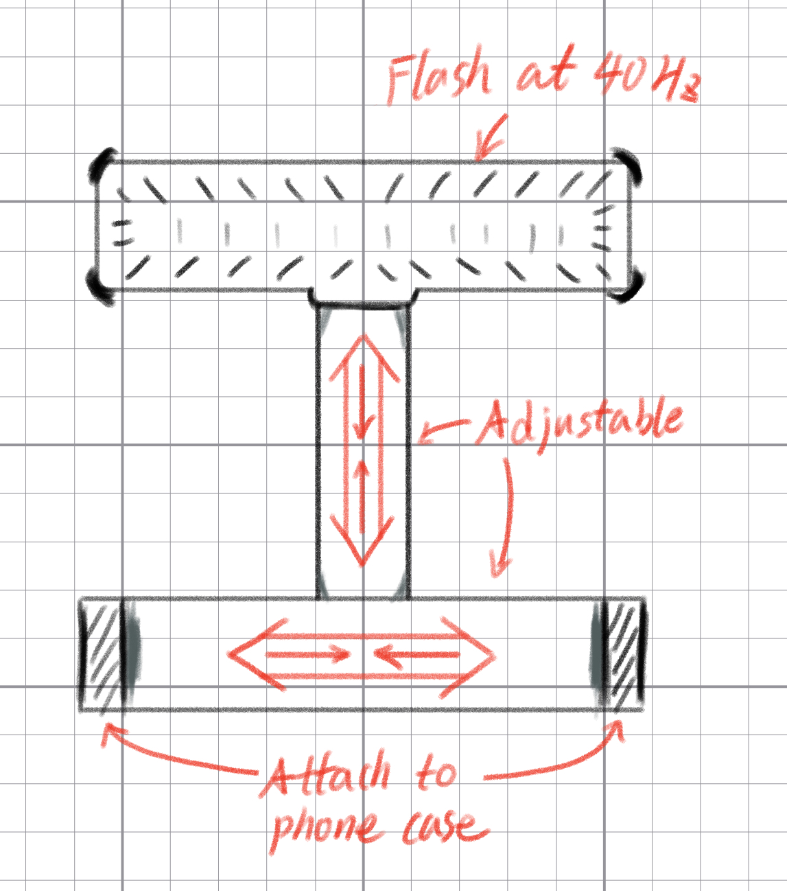

*Figure 1.1 Universal LED Light Fixture Design*

This illustration showcases a universal LED light design adaptable to the majority of smartphones. The design allows the LED light to be affixed to the back of the phone, emitting light at a preset frequency of 40Hz towards the user.

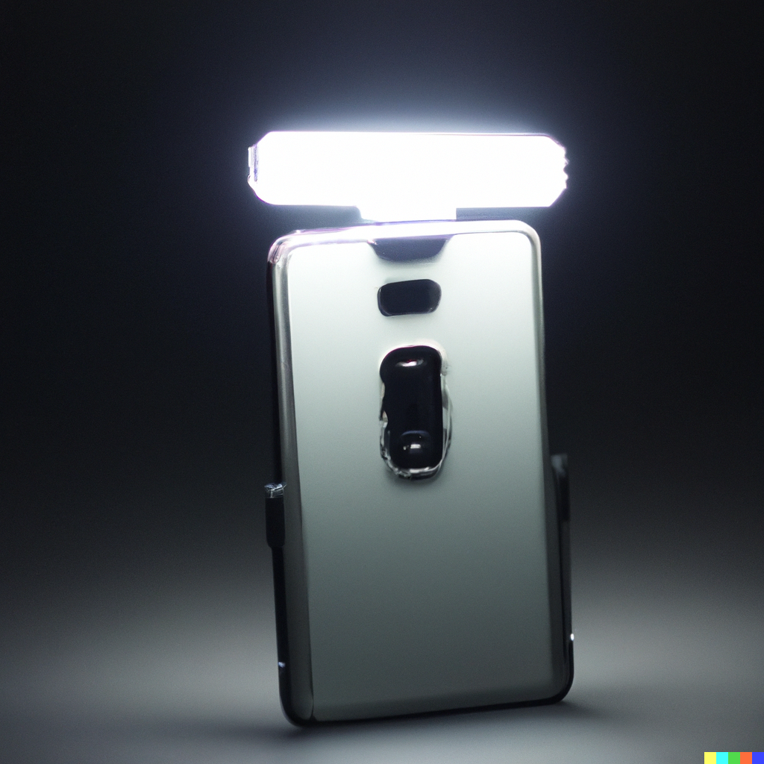

*Figure 1.2 Universal LED Light Design AI Rendered Image*

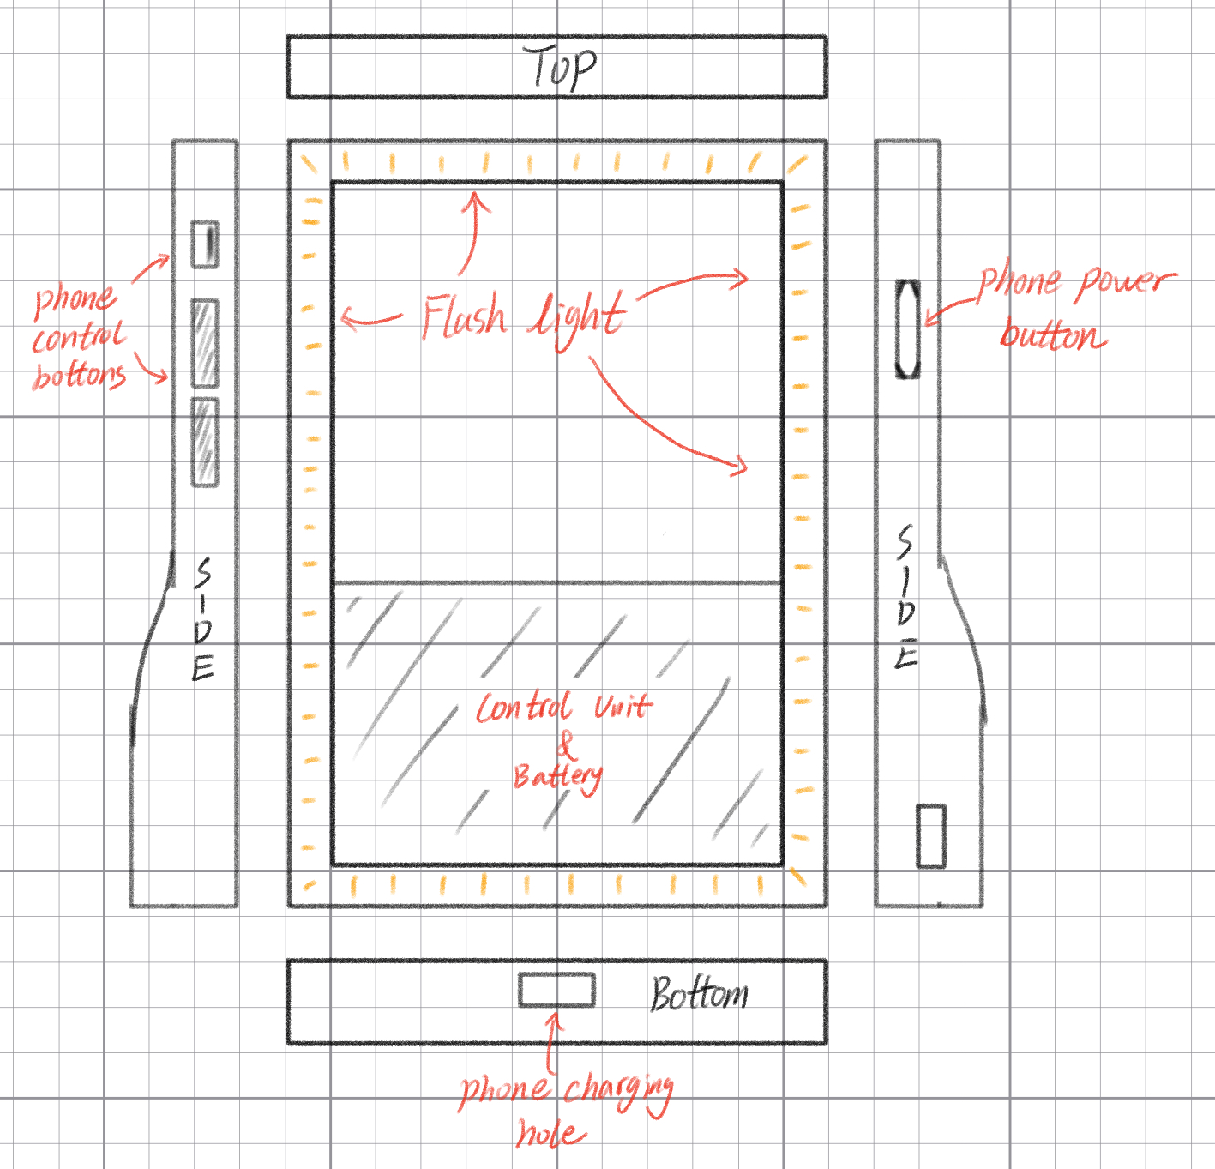

*Figure 2.1 Battery-Powered Smartphone Case Design*

This figure presents a design of a smartphone case equipped with a battery-driven lighting system. The lights are strategically positioned around the perimeter of the case, facing the user. Integrated within the case is a control system that allows users to adjust the brightness and toggle the lights on or off, providing a seamless experience for the user while ensuring the therapeutic benefits of the 40Hz light treatment.

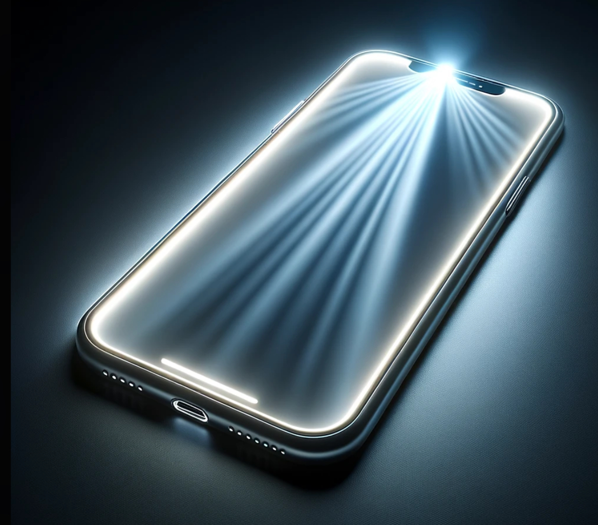

*Figure 2.2 Battery-Powered Smartphone Case Design AI Rendered Image*

# 4 Competing Technologies

The major competitors in this space include traditional pharmaceuticals, brain-stimulating apps (like Lumosity), wearable devices, and non-invasive brain stimulation techniques.

## 4.1 Traditional Pharmaceutical

Traditional pharmaceuticals have been the cornerstone of Alzheimer’s disease treatment for years. Medications such as Donepezil, Galatamine, and Memantine, are designed to manage Alzheimer’s symptoms and slow cognitive decline[6]. Requirements for such pharmaceuticals include rigorous clinical trials, regulatory approval, safety assessments, defined dosage, and administration procedures.

## 4.2 Lumosity and Brain-Stimulating Apps

Lumosity, along with other brain-training apps, offers cognitive exercises and games that aim to enhance memory, attention, and other cognitive skills. Requirements include scientific validation, user-friendliness, personalization, data privacy, accessibility, and progress tracking. These apps often need to demonstrate their effectiveness through research studies.

## 4.3 Wearable Devices

Wearable devices, such as smartwatches and fitness trackers, are used for monitoring health metrics and detecting changes in daily activities and routines, which can be early indicators of cognitive decline. These technologies require technical stability, data privacy, and accuracy in health monitoring.

## 4.4 Non-Invasive Brain Stimulation Techniques

Non-invasive brain stimulation techniques like transcranial magnetic stimulation (TMS) and transcranial direct current stimulation (tDCS) aim to improve cognitive function [7]. Requirements include safety, efficacy, personalized treatment plans, and scientific validation.

# 5 Engineering Requirements

## 5.1 Features

1. 40 Hz flashing light
2. Compatible with all smartphone models
3. Can be controlled independently from phone
4. Portable with the smartphone
5. Intuitive and easy user interface

## 5.2 Constraints

This device is meant to easily attach and detach to all smartphone models, as well as being portable. Given these requirements, we have decided that it is necessary for the device as a whole to be no larger than a standard iPad or tablet case.

We are also working with a budget constraint which limits the complexity of the parts we can use for our device. However, this issue is not particularly pressing as we have $750 and our current projected cost per unit is under $100.

## 5.3 Technology

Currently for our device we are planning to use a micro-controller that will determine the rate at which the light will be flashing as well as the light intensity. The controller is an Infineon PSoC 4 microcontroller. We will also be using LED lights that will surround the user’s smartphone.

This device will be used in combination with a smartphone, but will operate with fairly simplistic user inputs. Such as buttons or switches.

In the initial prototype there will be very little in terms of adjustability and added features, however, the microcontroller will be programmed to allow for future changes in the code that will update and enhance the device.

## 5.4 Feedback Data

The initial prototype for this device is set to be completed by the end of 2023 calendar year in order to allow for use in a trial setting. Result data from the performance of the device will be collected and used to determine next steps on performance improvement or addition of features.

**Acknowledgment**

The authors wish to thank Dr. Vyshedkiy for the opportunity to work on this project, as well as Professor Osama Alshaykh for his input and support.

**References**

1. Alzheimer's Association. “Facts and Figures.” *Alzheimer’s Disease and Dementia*, Alzheimer’s Association, 2023, www.alz.org/alzheimers-dementia/facts-figures.
2. “An Observational Trial of Alzheimer’s Disease Treatment with Combination of 40Hz Light and Cognitive Therapy | Alzheimers.gov.” *Www.nia.nih.gov*, www.alzheimers.gov/clinical-trials/light-and-cognitive-therapy-alzheimers-disease?%20. Accessed 19 Oct. 2023.
3. D. Chan *et al.*, “Gamma frequency sensory stimulation in mild probable Alzheimer’s dementia patients: Results of feasibility and pilot studies,” *PLOS ONE*, vol. 17, no. 12, 2022. doi:10.1371/journal.pone.0278412
4. ‌Magsamen, Susan. “How Simple Sound and Light Are Treating Alzheimer’s Disease.” *FastCompany*, www.fastcompany.com/90867531/how-simple-sound-and-light-are-treating-alzheimers-disease. Accessed 20 Oct. 2023.
5. OpenAI. “DALL·E 2.” *OpenAI*, 2023, openai.com/dall-e-2.
6. “Medications for Memory, Cognition and Dementia-Related Behaviors.” *Alzheimer’s Disease and Dementia*, www.alz.org/alzheimers-dementia/treatments/medications-for-memory. Accessed 20 Oct. 2023.
7. “Alzheimer’s Therapies: Brain Stimulation.” *WebMD*, WebMD, www.webmd.com/alzheimers/brain-stimulation-alzheimers. Accessed 20 Oct. 2023.